Project: Marketing Campaigns

Hypothesis 1: Older people are not as tech-savvy and probably prefer shopping in-store.

Null Hypothesis seems true as we can see the people with age >60 are more prefer to buy from stores.
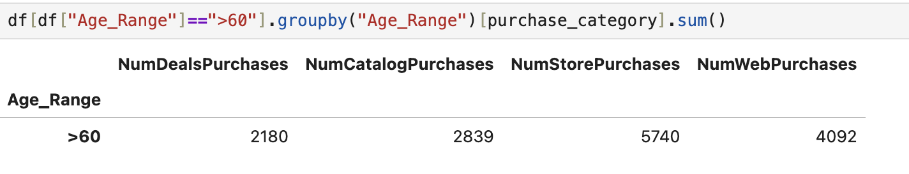

Hypothesis 2: Customers with kids probably have less time to visit a store and would prefer to shop online.
- this hypothesis is false from the data we can see the people who have kids(1,2,3) are more preferring to buy from stores

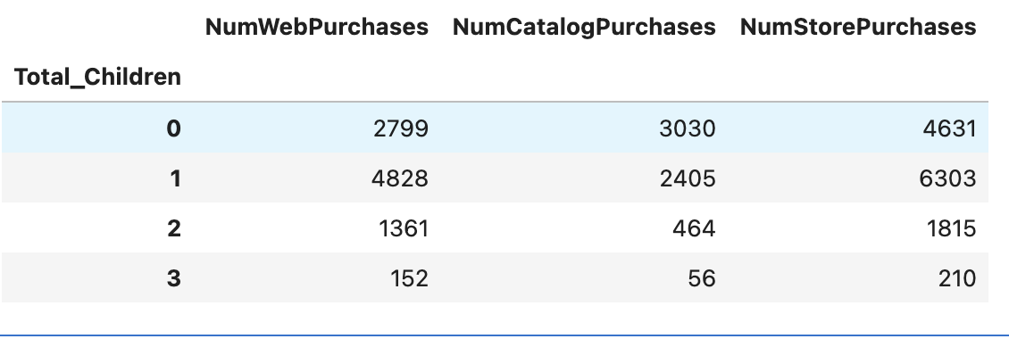

Hypothesis 3: Other distribution channels may cannibalize sales at the store.
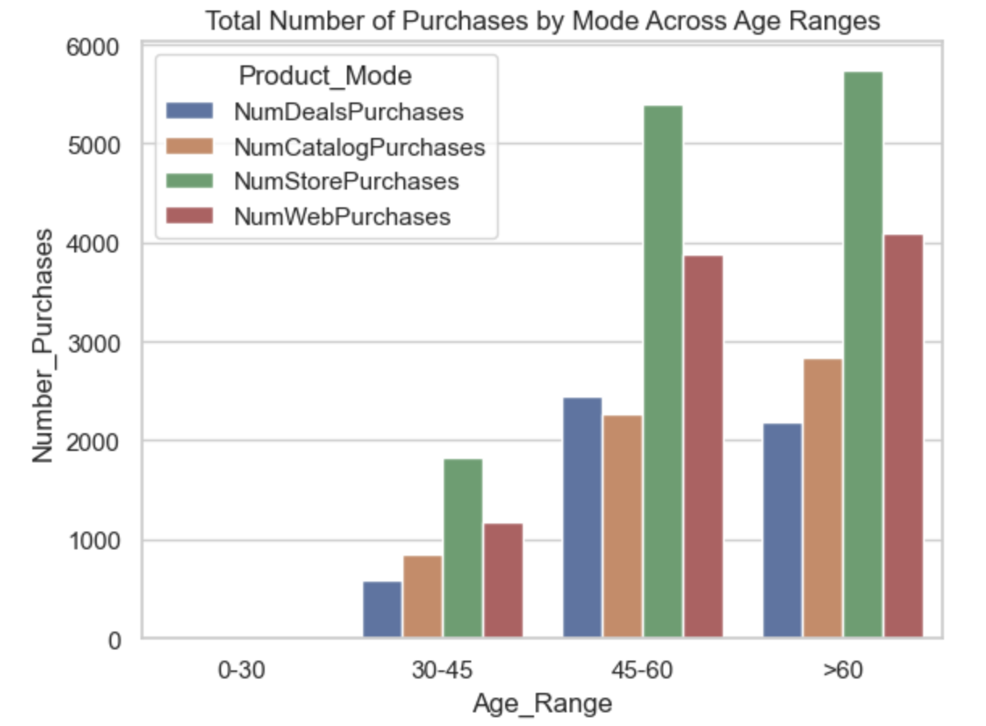
Yes, as we can see the all age range people are more prefer to buy from stores, so we can open mode outlets to increase the sales.
Hypothesis 4: Does the US fare significantly better than the rest of the world in terms of total purchases?
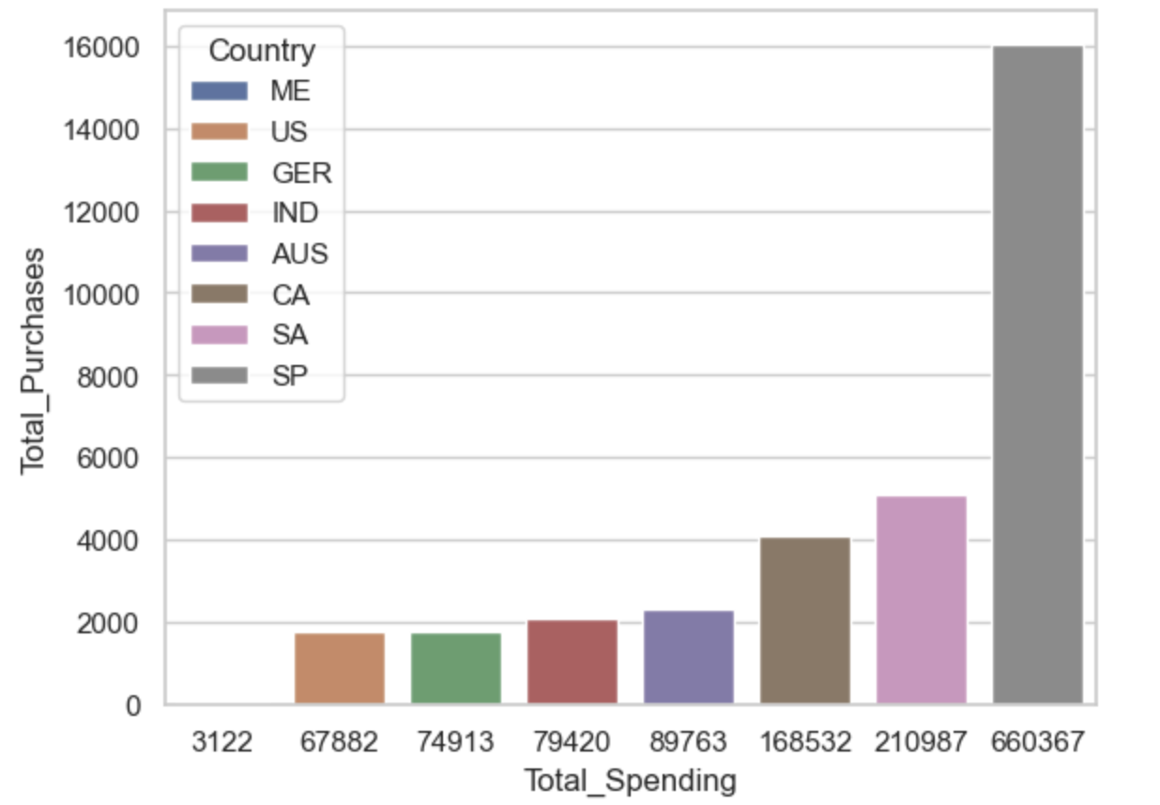No , this hypothesis is fasle, US has very less number of purchase as compare to other country, the SP and SA have very large purchases.

Visualization and Analysis -

Which products are performing the best, and which are performing the least in terms of revenue?
- The Wine and Meat Product are the top two best performer

Is there any pattern between the age of customers and the last campaign acceptance rate?
- 

Which Country has the greatest number of customers who accepted the last campaign?
- Spain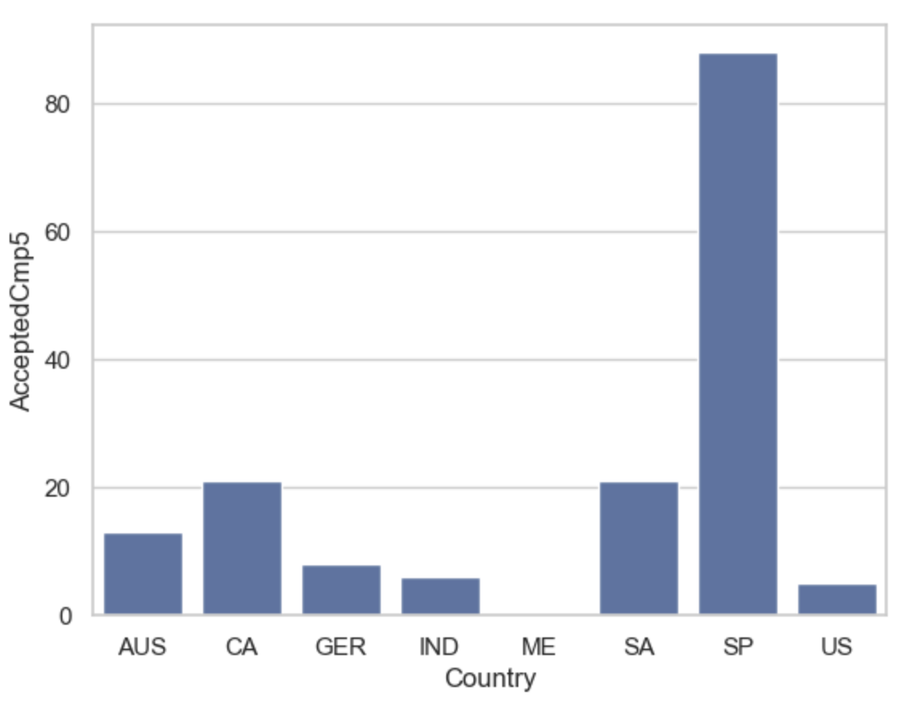

Do you see any pattern in the no. of children at home and total spend?
Yes we see a negative correlation - the more the child the less the spen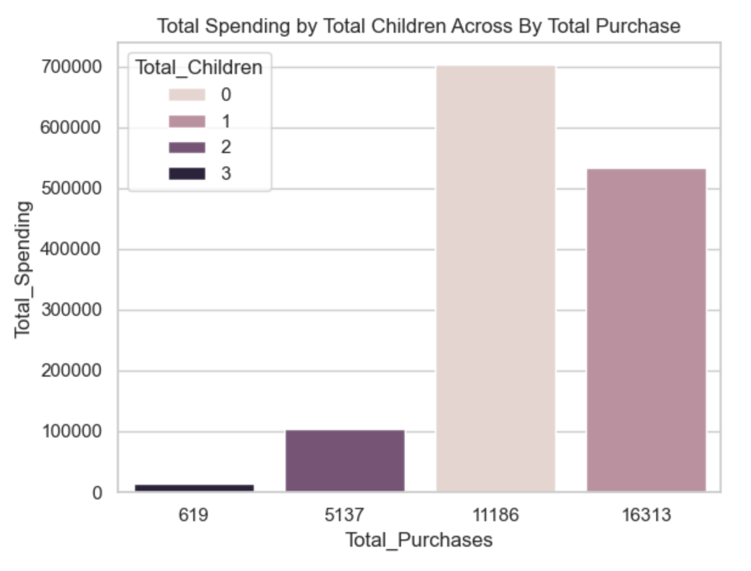d.

Education background of the customers who complained in the last 2 years.

